Choice #1
Complete a “How-to” Drawing.
There are choices below or you can view an Art for Kids Hub video on YouTube (please write title of chosen video on back of your paper). Add detail and color to your drawing!

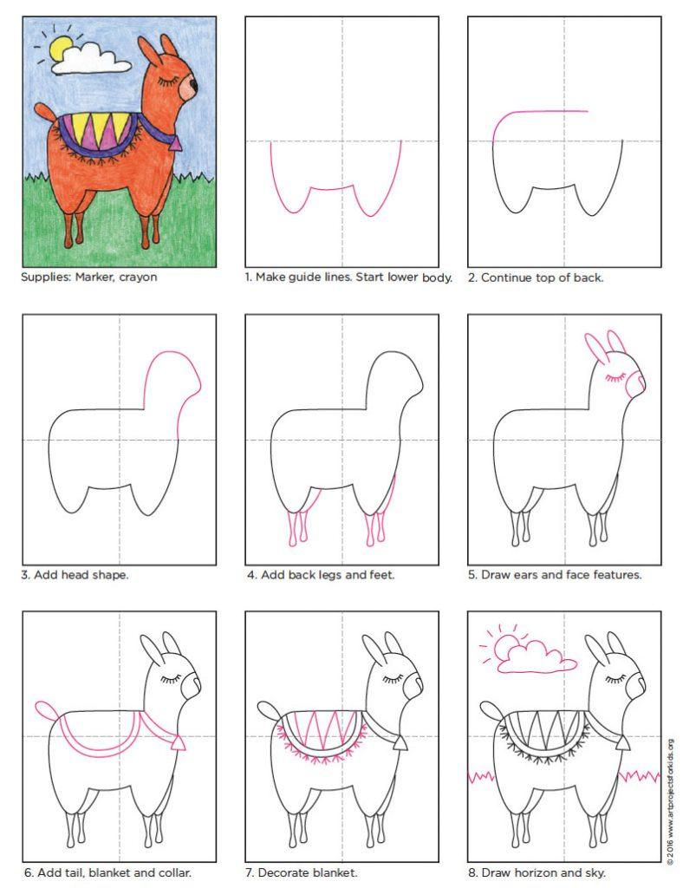
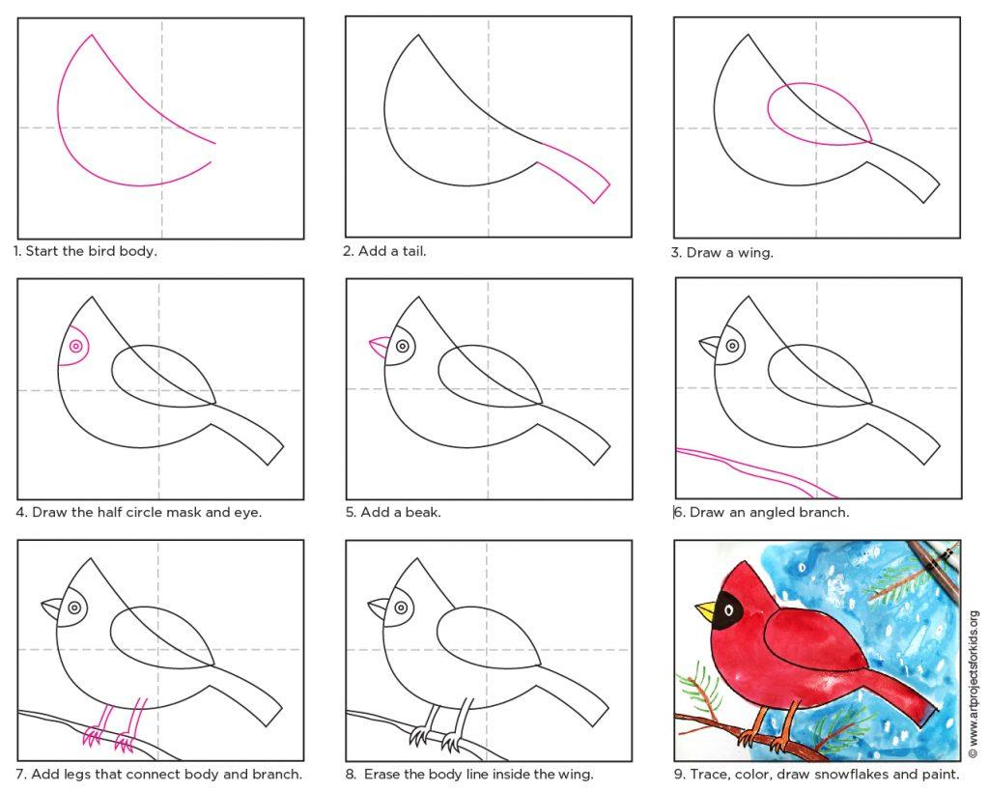

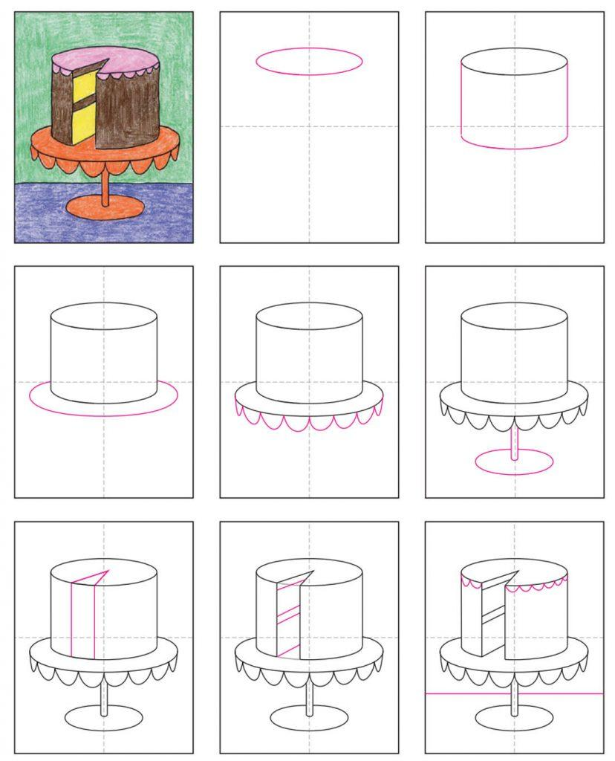

Choice #2
Sort objects in your house by color. You can choose any of the color groups below:
- Primary colors (red, yellow, blue)
- Secondary colors (purple, green, orange)
- Cool colors (green, blue, purple)
- Warm colors (red, orange, yellow)
Have at least 3 objects in EACH color group (i.e. 3 red objects, 3 yellow objects, 3 blue objects). Take a photo of OR draw, color and label the organized objects.

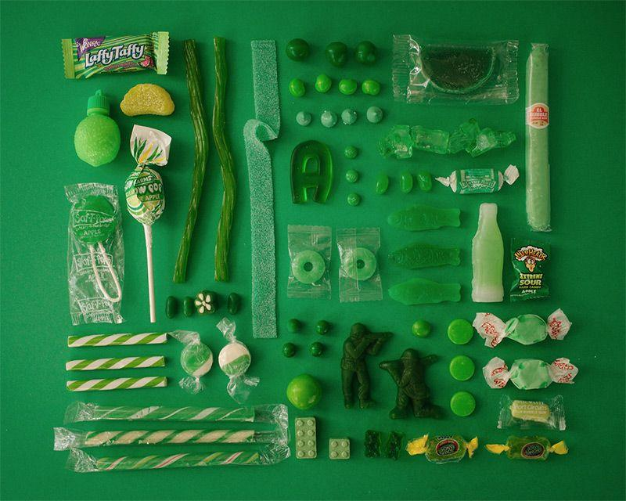

Choice #3:
Using recyclable items in your house (toilet paper rolls, cereal boxes, wrappers, bottle caps, etc.), create a sculpture. Your sculpture should use at least 4 or more items. Take a photo of OR draw, color, and label your sculpture.

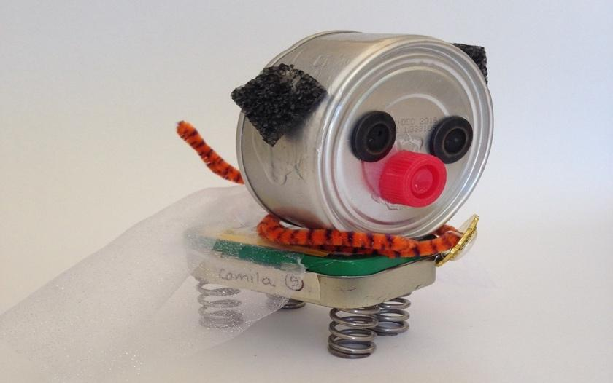

Choice # 4: Color the bookmark then design your own.

Choice #5:
Watch the video below of the “Scribble Challenge.” *You do not NEED to watch this video to complete this project – it is only an example!
https://youtu.be/bkKIRfDwFfI

Materials needed:
- White paper (you can use the backside of this paper)
- Black marker or pen
- Pencil
- Coloring supplies of choice (colored pencils, markers, crayons, paint, etc.).

Steps:
- Close your eyes and make a random scribble with a black marker or pen.
- Open eyes and brainstorm what you could turn your scribble into… think DETAILS!
- Using a pencil, draw something new out of your scribble.
- Color your drawing neatly and add details.
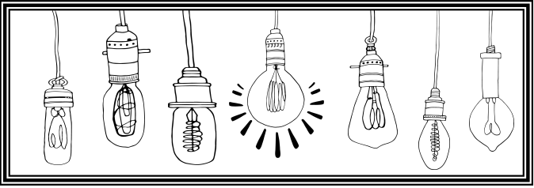
- Finished ☺

